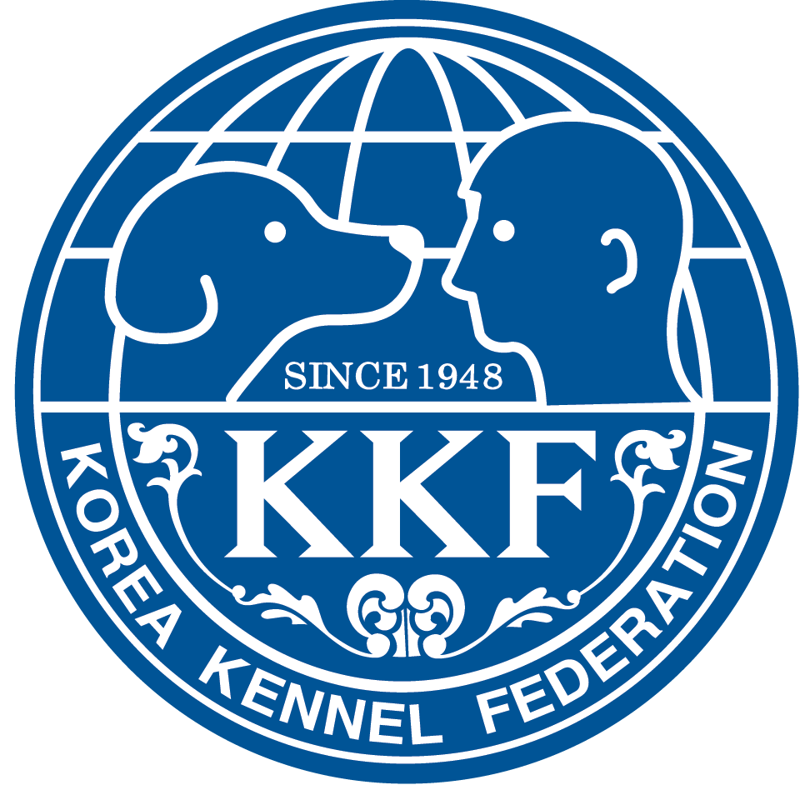
2024 Korea Premier Dog Show Entry Form
▫ SHOW(※ Please check the show you wish to enter.)
□ FRIDAY FCI International Dog Show □ FRIDAY KKF Championship Dog Show
□ SATURDAY FCI International Dog Show □ SATURDAY FCI A2O Championship Show
□ SATURDAY KKF Championship Dog Show
□ SUNDAY FCI A2O Section Show(Crufts Qualifying Show) □ SUNDAY FCI A2O Championship Show
□ SUNDAY KKF Championship Dog Show
▫ Dog Information
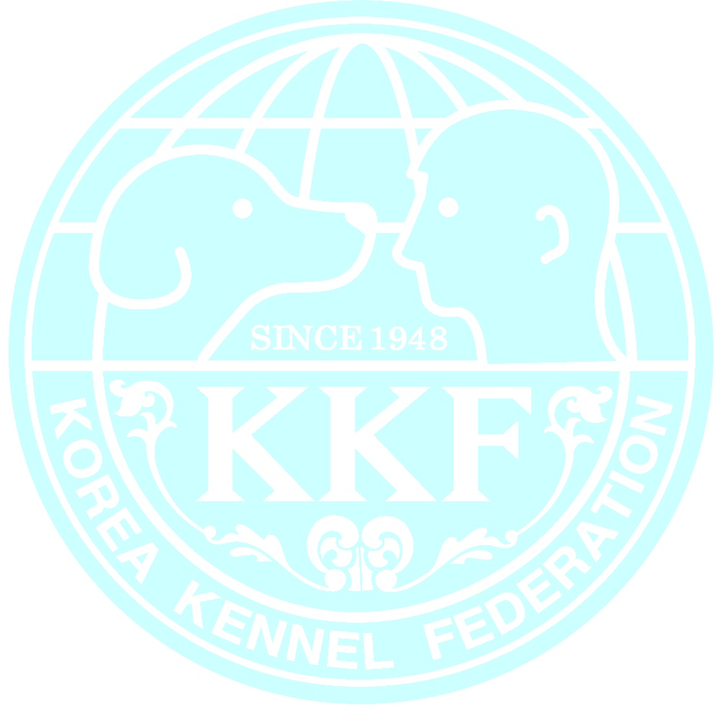  ▪ Breed |  | ▪ Registration No.
▪ Sex □ Male □ Female | ▪ Size/ Color/ Coat |  | ▪ Date of Birth
▪ Name of the dog
▪ Name of Sire |  | ▪ Name of Dam
▪ Name of Breeder
※ Please enclose a copy of the pedigree as well as championship documentation.
▫ Class
Baby  (3-6months) | Puppy  (6-9months) | Junior  (9-15months) | Intermediate  (15-24months) | Open  (above 24months) | Champion  (above 15months) | Veteran  (above 8years)
※ Champion Class entries must be accompanied by a proof of entitlement. Otherwise the dog will automatically be admitted in the other Classes.
▫ Owner
▪ Name | ▪ Street
▪ ZIP/Town | ▪ Country
▪ Telephone | ▪ E-mail
▫ Exhibitor
▪ Name | ▪ Country
※ When different from the owner of the dog filled in above.
With his/her signature, the exhibitor promises to abide by the KKF show regulations and veterinary rules. The entry is financially binding.
Date :
Signature :
※ Entries must be sent by e-mail(thekkf@thekkf.or.kr) or fax(+82 2 2277 4073) with all documentation.
※ Wire Transfer - Beneficiary Name: KOREA KENNEL FEDERATION, Beneficiary Account Number: 140-005-427759 Full Address: 5F, 12 gil 19, Cheonhodae-ro, Dongdaemun-gu Seoul, Republic of Korea, Swifit Code: SHBKKRSE, Bank Name: SHINHAN BANK, Full Address of Bank: 255, Namgye-ro, Jongno-gu, Seoul, Republic of Korea
※ Paypal: thekkf@thekkf.or.kr (Name: Wol Nam Jeon [Secratery General of the Korea Kennel Federation])

